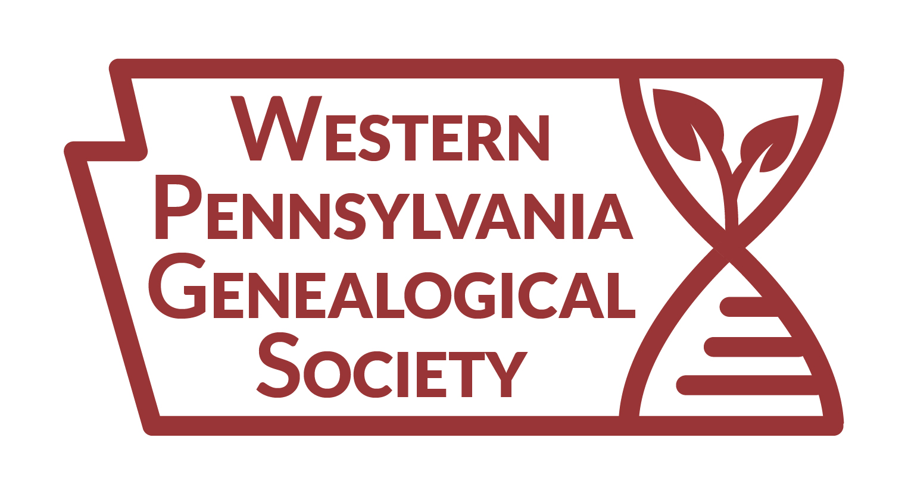

2024-2025 Suzanne Johnston
Memorial Scholarship Application

Your name: Member # Applicant’s Conference Choice: Conference URL: Date(s):
Criteria for Scholarship
ᵒ Describe why you chose this particular conference.
Was it the speakers? The syllabus? The location?
ᵒ Explain how you expect that this conference will help your family history research.
ᵒ Describe how this conference might aid in a research issue specific to Western Pennsylvania, if any.

ᵒ If you chose this conference because it offered information you could not get elsewhere, explain your reasoning.
ᵒ Make your response readable, using proper grammar, punctuation, and sentence structure.
ᵒ Stay within the required 250-400 word limit.

How Attendance at an Upcoming Genealogical Conference Will Benefit my Family History Research

Also, briefly describe any genealogical training. This may be a separate document and does not need to be part of the word count.

The deadline for receipt of Application for 2025 conferences is 31 December 2024. The winner will be announced by late February 2025. We will publish the winner in the Jots from Western Pennsylvania newsletter.
Mail your application to Scholarship, Western Pennsylvania Genealogical Society, 4400 Forbes Avenue, Local History & Genealogy, Pittsburgh, PA 15213-4007, or email a completed PDF to scholarship@wpgs.org. Address any questions and/or comments to this email as well.

