HOTEL | ADDRESS | Walk/Drive Distance to UC |  | Est. Pricing  /night * | AMENITIES
- Wyndham Pittsburgh University Center (changing to Marriott Courtyard in April 2024) | 100 Lytton Avenue  15213 | 7 min. walk  (.3 mile) |  | $179 WPGS Room Block June 20, 21, and 22, 2024. | WiFi, Fitness Center, Parking (Fee), Indoor Pool, Smoke-Free, Local Shuttle
- Oaklander (Marriott Bonvoy) | 5130 Bigelow Boulevard  15213 | 5 min. walk  (0.2 mile) |  | $249+ | WiFi, Fitness Center, Parking (Fee), Smoke-Free, No Shuttle Service
- Hilton Garden Inn Pittsburgh University Place | 3454 Forbes Avenue  15213 | 0.4 mile walk (9 min.) |  | $165-210 | Breakfast buffet, WiFi, Fitness Center, Parking (Fee), Indoor Pool, Smoke-Free, Local Shuttle
- Residence Inn Pittsburgh Oakland/University Place | 3141 Forbes Avenue  15213 | 14 min. walk  (0.7 mile) |  | $180-200 | Breakfast, WiFi, Limited Parking (Fee), Local Shuttle, Smoke-Free
- Hampton Inn Pittsburgh University/Medical Center | 3515 Hamlet Street  15213 | 15 min. walk  0.75 mile |  | $130-150 | Breakfast, WiFi, Fitness Center, Limited Parking (Fee), Local Shuttle, Smoke-Free
- SpringHill Suites by Marriott Pittsburgh Southside Works | 2950 South Water Street  15203 | 9 min. drive 1.6 mile walk |  | $150-160 | WiFi, Free Breakfast, Parking (Fee), Smoke-Free, Fitness Center, Indoor Pool, Fitness Center, No Shuttle
- Hotel Indigo Pittsburgh University-Oakland (IHG Hotel) | 329 Technology Drive  15219 | 7 min. drive  1.2 mile walk |  | $125-130 | WiFi, Parking (Fee), Breakfast ($), Smoke-Free, Fitness Center, Shuttle Arrangements
- Holiday Inn Express & Suites Pittsburgh-South Side (IHG Hotel) | 20 South 10th Street  15203 | 10 min. drive 3.2 mile walk |  | $125-130 | WiFi, Free Breakfast, Parking (Fee), Indoor Pool, Fitness Center, Smoke-Free, Airport Shuttle but No Local Shuttle
- Hyatt House Pittsburgh-South Side | 2795 South Water Street, 15203 | 9 min. drive 1.7 mile walk |  | $215-250 | WiFi, Free Breakfast, Parking (Fee), Indoor Pool, Fitness Center, Smoke-Free, No Shuttle
www.airbnb.com 15213 |  |  | www.vrbo.com 15213
* Hotel rewards may offer discounts.
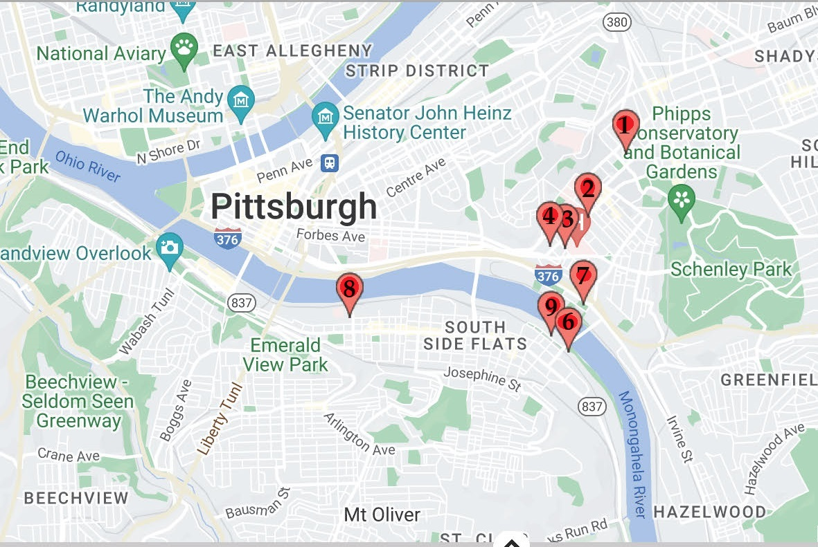
5

